(D) Wall Shear Stress (WSS) Quantitative Analysis (Non-Newtonian, Model 2, 70:30 Flow Division).
1. Temporal WSS Distribution at Specific Points.
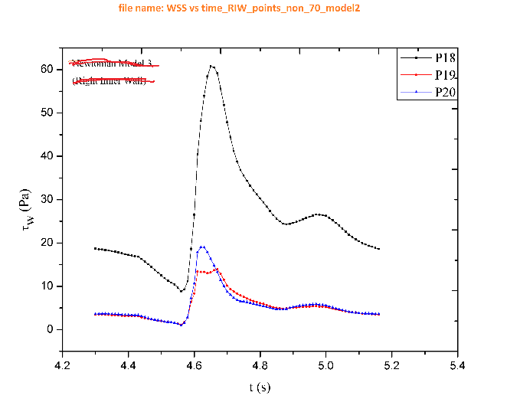 | 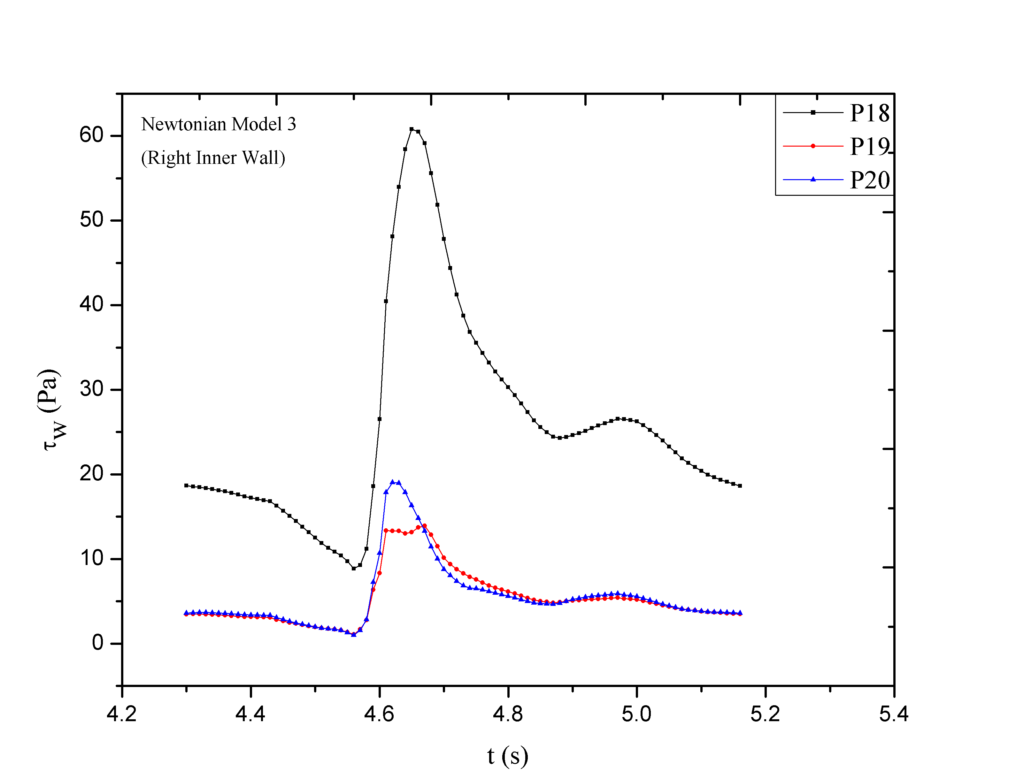
a) WSS at Left Outer Wall | b) WSS at Right Outer Wall
c) WSS at Left Inner Wall | d) WSS at Right Inner Wall

2. Temporal WSS Distribution at Specific Times.
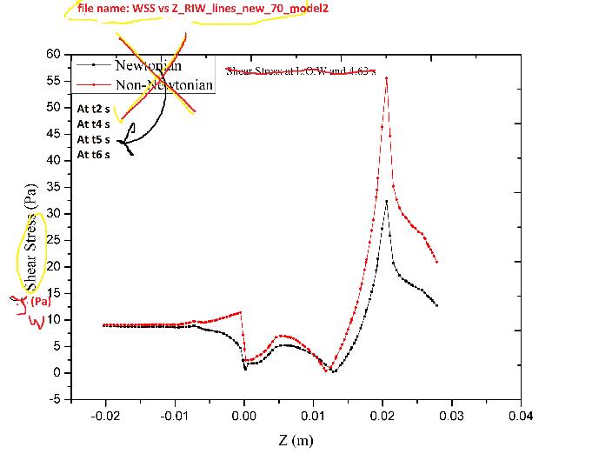
a) WSS at Left Outer Wall | b) WSS at Right Outer Wall
c) WSS at Left Inner Wall | d) WSS at Right Inner Wall

